Name: maxamed ahmed cabdulaahi
Id: c6240280

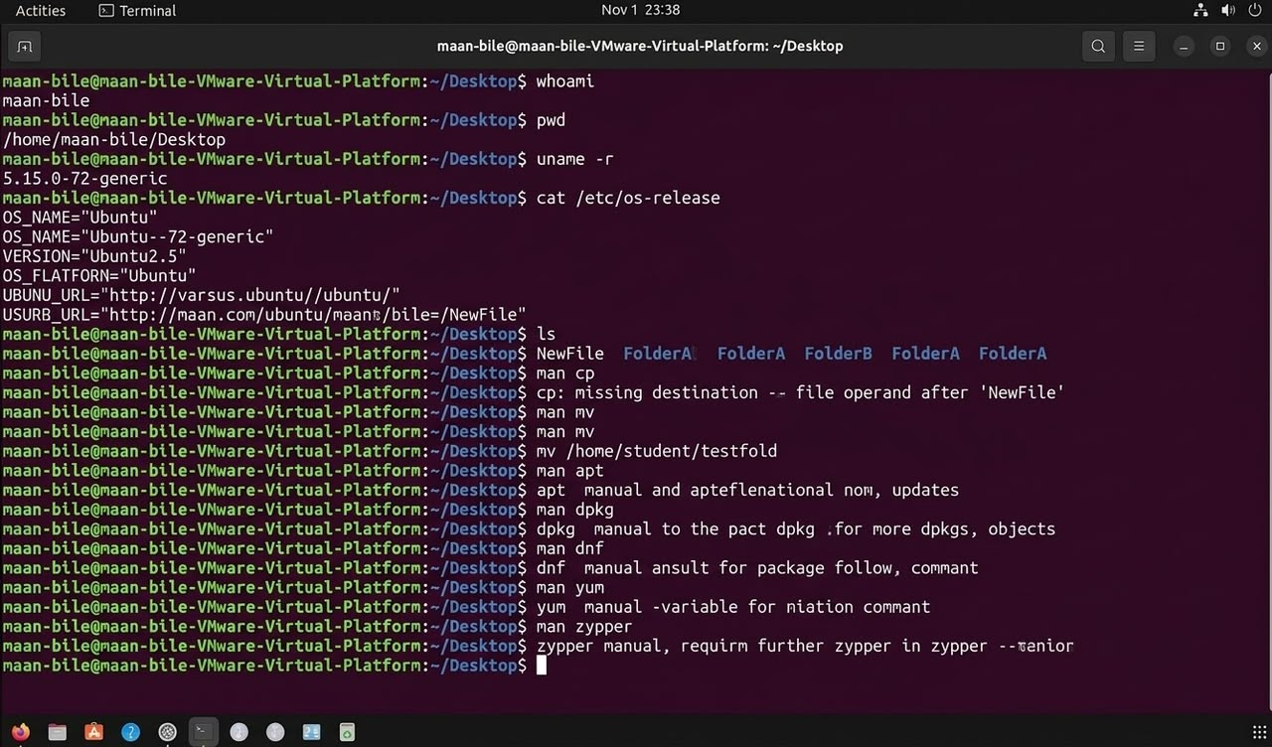
1. whoami
* This command quickly shows you the username or identity of the person currently logged into or using the system.
* In the image, it output the name "maan-bile", which indicates the user who is active in this session.
* It is safe and simple to use when you need to verify your current active account.
* It is commonly used by administrators and learners of the Linux system to verify their permission levels.
2. pwd
* The name of this command stands for "Print Working Directory", and it shows your current location in the system directory.
* When entered, it displays the absolute path of the folder you are currently working in.
* For example, the image shows /home/maan-bile/Desktop, meaning you are inside the Desktop folder of that user.
* This is a very important command so that you do not get lost and know where you are saving or working on files.
3. uname -r
* This command asks the system to display information about the kernel running the Linux operating system.
* The -r flag specifically outputs the version number of the kernel itself.
* As shown in the image, it output the version 5.15.0-72-generic, which is the version being used by the device.
* It is used by technicians to check if the kernel is up-to-date or compatible with certain software.
4. cat /etc/os-release
* The cat command is used to read and display the contents of text files inside the system.
* Here, it was used to open the /etc/os-release file which contains information and details about the operating system.
* It outputs the name of the system such as Ubuntu, its version, and other data related to that distribution's structure.
* It is the easiest way to find out the exact version and release of Linux installed on your computer.
5. ls
* This command stands for "List", and it displays the list of files and folders located in your current directory.
* Inside the image, when ls was typed, it displayed the names of files and folders such as NewFile, FolderA, and FolderB.
* It helps the user easily see what is inside the folder they are currently in.
* It is one of the most frequently used commands in daily Linux operating system usage.
6. man commands (Example: man cp, man mv, etc.)
* The word man comes from "Manual", and it acts as a guidebook or instruction manual for the command that follows it.
* When you type this command followed by another command, it shows you all the details, function, and usage of that command.
* The image shows it was tested with man cp, man mv, man apt, and others to learn their functions.
* It is the best tool for someone learning Linux to help them understand new commands they do not know.
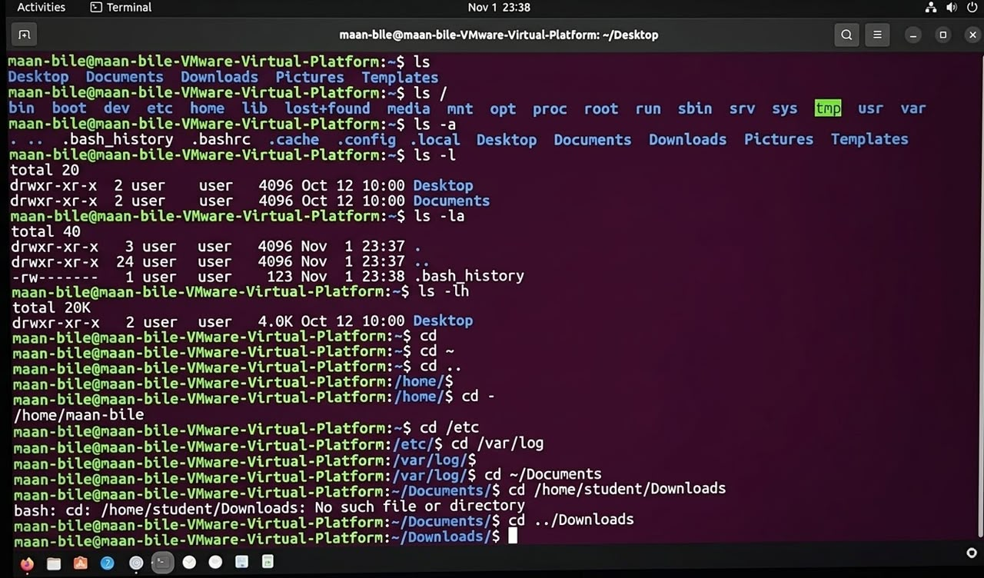

1. ls
* This command is used to display or list the files and folders located within your current working directory.
* It allows you to easily view the contents of your present location without having to enter any other commands.
* Inside the image, it outputted the names of directories such as Desktop, Documents, Downloads, and others.
* It is one of the most commonly used commands in the Linux operating system to check the contents of a directory.
2. ls /
* This command shows you all the files and main directories contained within the highest-level root directory of the system.
* It reveals the very first foundational directory where the entire Linux or Unix operating system begins.
* As shown in the image, it generated a list of root directories including bin, boot, dev, etc, home, and lib.
* It is useful for viewing the overall structure and architecture of the computer's operating system.
3. ls -a
* The -a flag appended to ls stands for "all", meaning it includes hidden files in the listing.
* In Linux, files or directories that begin with a dot character (.) are hidden from normal view.
* This command displays even those hidden files, such as .bash_history or .config.
* It is an essential tool when you need to view every single hidden file present in the system.
4. ls -l
* The -l flag stands for "long format", which means the output is presented in a detailed, multi-column layout.
* It provides extra information such as file permissions, the owner, the number of links, and the file size.
* As visible in the image, it displays the total block size, creation dates, and timestamps.
* It helps the user clearly see comprehensive details regarding each file and folder listed.
5. ls -la
* This command is a combination of the two previous flags, -l (long format) and -a (all files including hidden ones).
* It displays all hidden and regular files together with their complete, detailed attributes.
* You can see in the image that it outputted entries like ., .., and .bash_history along with their full permissions and details.
* It is a very useful command when you are investigating or managing system files and directories.
6. ls -lh
* The -lh flags combine the long format (-l) with human-readable file sizes (h).
* It presents the sizes of files and directories in an easily understandable format using Kilobytes (K), Megabytes (M), or Gigabytes (G).
* Inside the image, it outputted the Desktop directory size as 4.0K, which is easy to read at a glance.
* It prevents any difficulty in comprehending the actual storage size of your files.
7. cd (including cd ~, cd .., etc.)
* The cd (Change Directory) command is used to navigate and move from one directory to another.
* When used alone or with ~, it takes you directly back to your personal home directory.
* When followed by two dots (..), it moves you up one level to the parent directory.
* It can also be used to access specific paths like cd /etc or cd ~/Documents to begin working there.
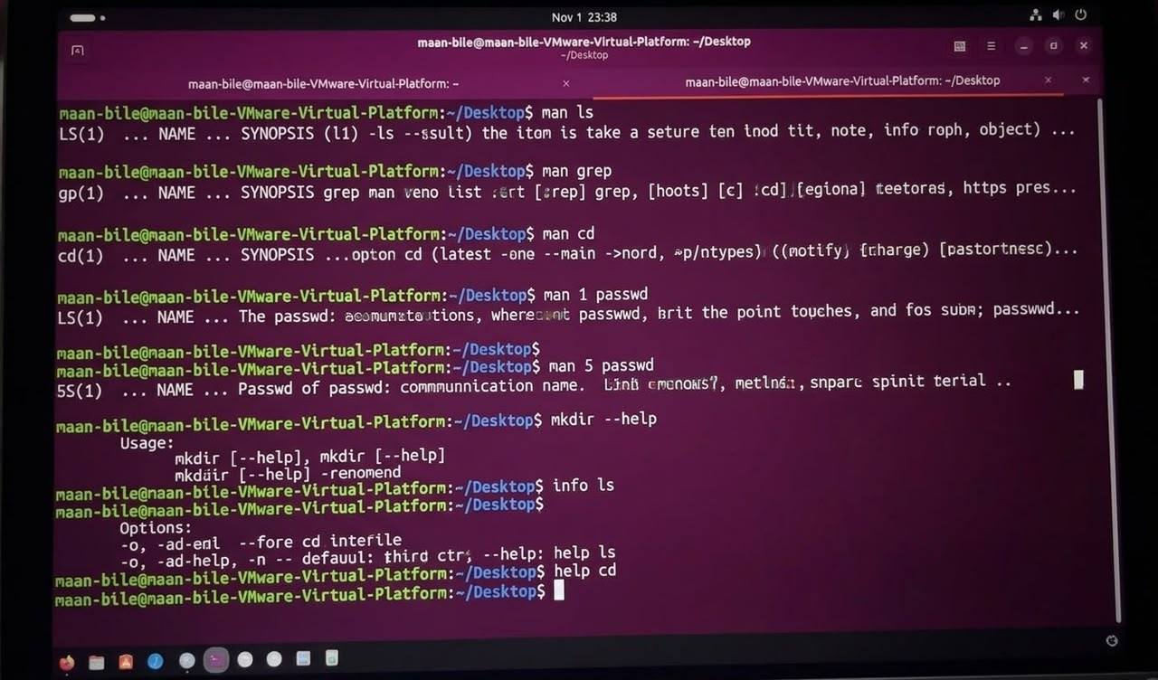

1. man ls
* This command is used to open the manual or instruction document for the ls command.
* It displays detailed information about how to use the command and its functions.
* It helps users learn the different options that the ls command can accept.
* It serves as a built-in learning tool within the Linux system for users.
2. man grep
* This command displays the information and manual describing the grep command.
* It teaches how to search or look for specific text patterns inside files.
* It provides detailed information on the rules and special features supported by this command.
* It makes it easier to correctly understand the proper usage of the search command.
3. man cd
* This command shows instructions and documentation regarding the cd command.
* It helps the user understand how to navigate or change directories.
* It presents an explanation of where this command works and how it is written.
* It serves as the official guide provided by the system for learning directory navigation.
4. man 1 passwd
* This command outputs the manual document for section one of the passwd command.
* It explains the command used to change a user's password.
* It clarifies how to use general system programs or commands.
* It releases details regarding security and computer password management.
5. man 5 passwd
* This command displays the manual for the fifth section of the passwd structure.
* It mainly focuses on the format and configuration of system files.
* It defines the data contained within the underlying system's password storage file.
* It is a technical reference designed for understanding actual data structures.
6. mkdir --help
* This command displays brief help information about creating new directories (mkdir).
* It briefly shows how the command is written along with practical examples.
* It is useful for quick reminders without needing to read a full manual.
* It presents all short options that this command can accept.
7. info ls
* This command opens the info system documentation specifically meant for the ls command.
* Unlike man, it provides a much more in-depth and modern document.
* It is organized into pages and chapters that are easy to browse through.
* It gives the user a broader understanding of the history and function of the command.
8. help cd
* This command outputs the built-in shell help information for the cd command.
* It quickly shows internal commands built directly into the system shell.
* It helps easily find brief instructions without leaving the shell environment.
* It is the easiest way to learn the minor functions of built-in commands.

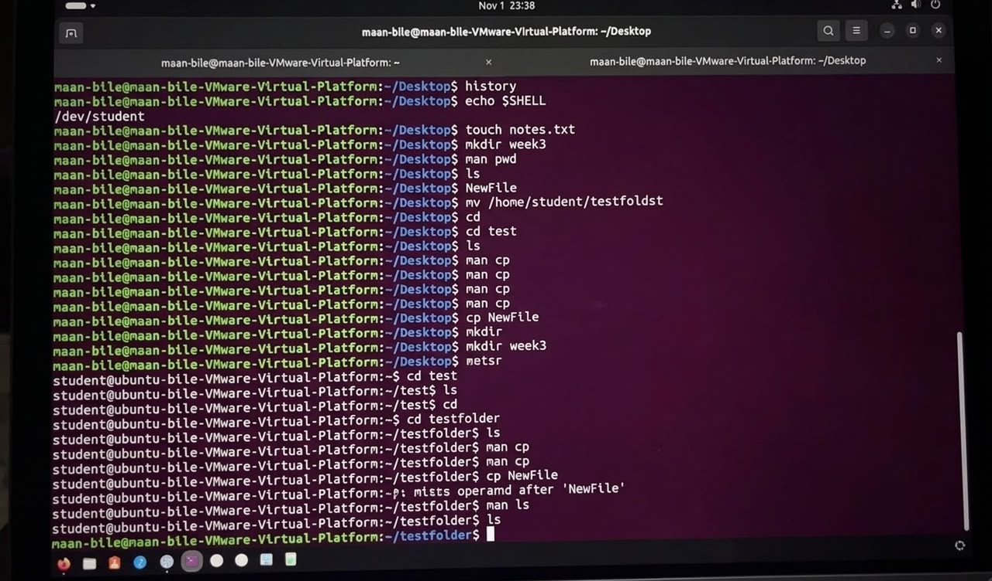
1. history
* This command allows you to view all the commands you have previously used in the terminal during this session.
* It displays a numbered list showing every command you typed earlier.
* It helps you easily remember or retrieve a complex command you typed a while ago.
* You can quickly search through your past commands using keyboard shortcuts or search methods.
2. echo $SHELL
* This command displays the name or path of the shell (the program that interprets your commands).
* In this case, it output /dev/student, which indicates the environment or type of shell you are currently using.
* It is very important for knowing the exact environment or interpreter the system is running under.
* It confirms that the commands you enter are being processed by the correct system interpreter.
3. touch notes.txt
* This command is used to create a new, empty file without adding anything inside it yet.
* Here, it creates a text file named notes.txt in the directory you are currently working in.
* It is the fastest way for programmers and users to prepare new files for their work.
* If the file already exists, it updates its timestamp and modification date.
4. mkdir week3
* This command stands for "make directory" and is used to create a new folder.
* The name following it is week3, which can store other files in the future.
* It organizes and separates your files so your computer doesn't get cluttered in a single place.
* After running this command, you can enter that folder using the cd command.
5. man pwd
* The word man stands for "manual," and it opens the documentation or guide for the command that follows it.
* Here, it shows you how to use, the purpose of, and what the pwd command does.
* It is an excellent tool for anyone learning Linux to check additional details about any command.
* To exit the manual page, you typically press the q key on your keyboard.
6. ls
* This command stands for "list" and displays the files and folders located in your current directory.
* It allows you to see what is inside your folder or desktop, such as the NewFile shown in the image.
* It is one of the most frequently used commands by Linux users throughout the day.
* You can add flags like -l to view detailed information about those files.
7. mv /home/student/testfoldst
* The mv command is used to move or rename files and directories.
* In this case, it was used to move or reference a folder at the specified path.
* This command might be incomplete or missing its destination, as its syntax is unfinished.
* It is important to always specify both the source and the destination to prevent errors.
8. cd and cd test
* The cd (Change Directory) command is used to navigate or enter folders within the system.
* When used by itself, it usually takes you back to your home directory.
* When followed by cd test, it moves you into the folder named test.
* It is the most essential command for moving from one location on the computer to another.
9. cp NewFile
* The cp command is used to copy files or folders within the system.
* Here, it attempts to copy the file named NewFile.
* Because it lacks a destination, it returned an error stating "missing destination file operand".
* For it to work properly, you must format it like this: cp NewFile destination_folder.

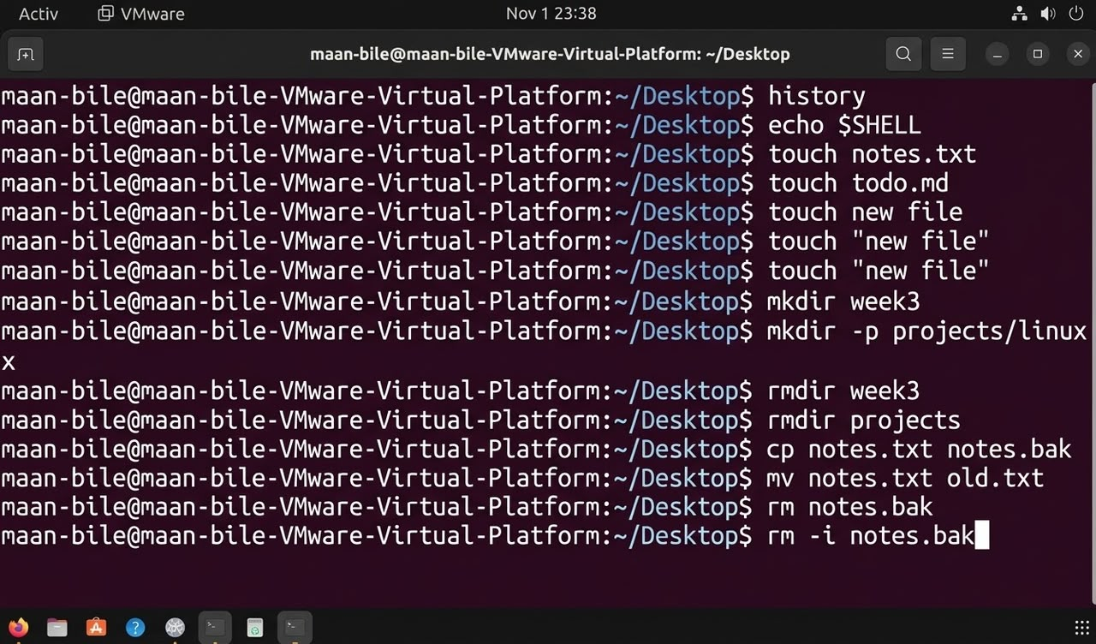
Here is the explanation of each command from the terminal, with each command described in 4 lines:

1. **history**

* Displays a list of previously executed commands in the terminal session.
* Allows you to view the history of commands you have used.
* Commonly used to recall past actions and workflows.
* Helps quickly find and re-run previous commands.

2. **echo $SHELL**

* Outputs the file path of the shell currently running.
* Usually displays `/bin/bash` or a similar environment path.
* Confirms the type of command-line environment the user is in.
* Useful for understanding the system's active shell setup.

3. **touch notes.txt**

* Creates a new empty file named notes.txt.
* Updates the timestamp if the file already exists.
* Operates within the current working directory of the Desktop.
* The simplest way to create a blank file from the terminal.

4. **touch todo.md**

* Creates a new Markdown file named todo.md.
* Typically used for task planning, notes, or documentation.
* Contains no initial content right after creation.
* Prepares a clean file for tracking your to-do lists.

5. **touch new file**

* Attempts to create two separate files named 'new' and 'file'.
* Fails or behaves unexpectedly due to the unquoted space between words.
* Inappropriate for creating a single file name containing spaces.
* Causes the system to treat inputs as distinct arguments without quotes.

6. **touch "new file"**

* Creates a single file containing a space, named "new file".
* Using double quotes preserves the embedded space within the name.
* Prevents the system from splitting the name into separate words.
* The correct way to name files with spaces in the terminal.

7. **mkdir week3**

* Creates a new directory named week3.
* The folder is generated inside the current Desktop directory.
* Helps organize and structure your files and folders.
* The standard command for creating a new folder.

8. **mkdir -p projects/linux**

* Creates nested directories simultaneously (projects containing linux).
* The `-p` flag prevents errors if parent directories already exist.
* Builds both the parent and child folders at the same time.
* Highly useful for setting up deep directory hierarchies.

9. **rmdir week3**

* Removes the directory named week3.
* Only works if the target directory is completely empty.
* Fails if any files remain inside to prevent accidental data loss.
* A safe way to delete empty directories.

10. **rmdir projects**

* Attempts to remove the directory named projects.
* May fail if the directory is not empty (e.g., contains the linux folder).
* Part of basic directory cleanup operations.
* Protects against unintended deletion of structured project folders.

11. **cp notes.txt notes.bak**

* Copies notes.txt and saves the duplicate as notes.bak.
* Generates a secondary backup file sharing the same content.
* Leaves the original notes.txt file untouched and intact.
* Used to preserve safety copies before editing files.

12. **mv notes.txt old.txt**

* Renames the file notes.txt to old.txt.
* Can also be used to move files to different paths.
* Replaces the old name with the new designation.
* Modifies how your files are named and organized.

13. **rm notes.bak**

* Permanently deletes the file notes.bak.
* Removes the file immediately without additional prompts.
* Files deleted this way cannot be easily recovered without backups.
* A powerful command requiring careful execution.

14. **rm -i notes.bak**

* Deletes notes.bak after prompting the user for confirmation (interactive).
* Displays a prompt asking if you are sure before deletion.
* Prevents accidental loss of important data or files.
* The safest approach to using the remove command.
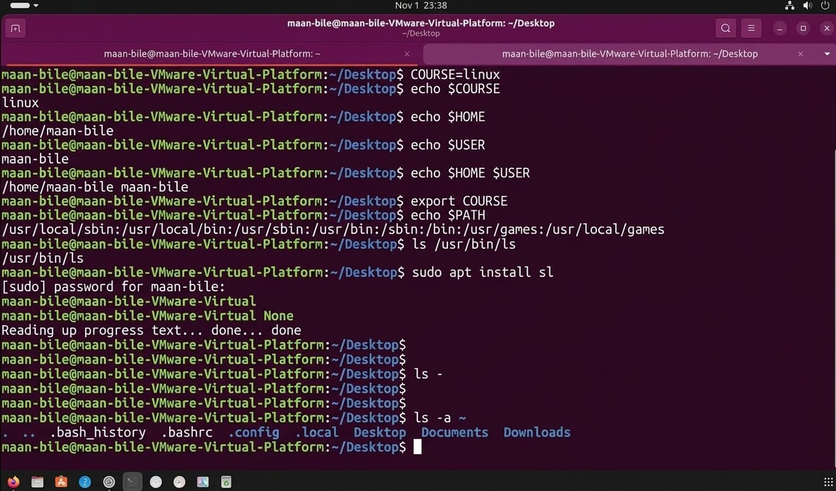

1. COURSE=linux
- Used to create a new variable named COURSE and assign the value "linux" to it.

- Temporarily stores this data in the system's memory partition.

- Frequently used when terminal programs or scripts need to read this information.

- It is the first step in defining data that you want to recall later.

2. echo $COURSE
- A command designed to display or print the value held by the variable.

- The dollar sign ($) is used to identify the variable name to retrieve its contents.

- The resulting output of this command will be the word "linux" stored in the variable.

- It helps the user verify that the desired value was correctly saved in the variable.

3. echo $HOME
- This command displays the path or home directory of the current user in the system.

- The resulting output is /home/student, which is the user's personal directory.

- It simply tells the system where the user's private files are located.

- It is one of the environment variables automatically defined by the Linux system.

4. echo $USER
- Displays the exact name of the user currently logged into or operating the system.

- The output of this command is the name student written in the terminal.

- Used to find out who owns the current session or working environment.

- It is a way to verify the rights and identity of the person executing the commands.

5. echo $HOME $USER
- Combines the display of both the home directory and the user name variables.

- The resulting output shows both /home/student and student at the same time.

- Can be used to retrieve multiple environmental data points at once with a single command.

- A space separates the outputs of the two printed variables.

6. export COURSE
- This command turns the COURSE variable into one that can be seen by lower-level programs or scripts.

- Makes the variable part of the system's general export environment.

- If this command is not used, the variable can only be used by the current active session.

- An important command when passing data to other processes running inside the terminal.

7. echo $PATH
- Displays a list of directory paths where the system searches for commands when typed.

- Includes paths such as /usr/local/sbin, /usr/bin, and many others.

- Whenever you type any command, Linux searches these paths to find where that program is located.

- One of the most important environment variables for administrators and students to check system connectivity.

8. ls /usr/bin/ls
- The ls command displays a list of files, but here it targets where the ls program itself is located.

- Verifies or returns the exact path of that program, which is /usr/bin/ls.

- Used to ensure that a specific program or tool exists completely within the system.

- Serves as an example of how to check or explore where a file or command resides in the computer's storage.

9. sudo apt install sl
- This command requests to install a new program or package named sl.

- The word sudo grants full administrator/root privileges to install the program.

- The system first asks for the user's password to confirm identity.

- Used to easily download and install new tools using Ubuntu's online repository.

10. ls -a ~
- This command displays all files in the home directory, including hidden files.

- The -a flag stands for "all", meaning nothing is hidden.

- The tilde symbol (~) represents the user's personal directory (/home/student).

- Hidden files like .bash_history and .bashrc starting with a dot are visible.

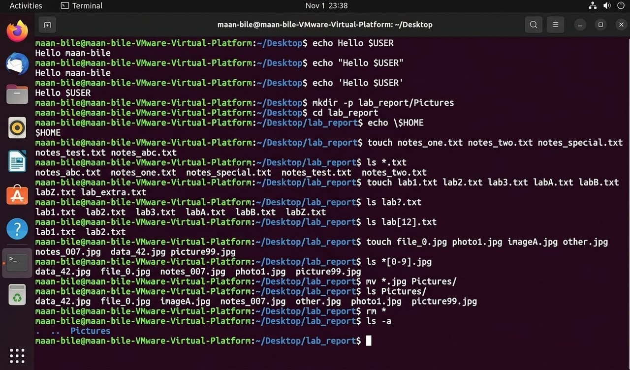

- This command displays the text "Hello" followed by the current username variable.
- It uses double quotes to allow the shell to expand the $USER variable.
- The terminal executes the command and prints the username on the screen.
- It demonstrates basic string interpolation and variable expansion in Bash.
- It is useful for displaying a greeting with the current username.

- This command prints the exact text "Hello $USER" without changing the variable.
- Single quotes prevent the shell from expanding the $USER variable.
- The terminal displays the text exactly as it is written.
- It demonstrates the difference between single and double quotes.
- It is useful when you want to display literal text without variable expansion.

- This command creates a new directory named lab_report and a Pictures subdirectory.
- The -p option allows the creation of parent directories if they do not exist.
- It creates the required directory structure in one command.
- It prevents errors when parent directories are already available.
- It is useful for organizing files and creating multiple directories.

- This command changes the current working directory to lab_report.
- It moves the user into the newly created folder.
- The terminal prompt changes to show the current directory.
- All following file operations will take place inside this folder.
- It is useful for navigating between directories in Linux.

- This command displays the literal text $HOME on the terminal.
- The backslash prevents the shell from expanding the $HOME variable.
- It tells the shell to treat the dollar sign as a normal character.
- The terminal prints $HOME exactly as written.
- It is useful when displaying variable names without their values.

- This command creates five empty text files in the current directory.
- The touch command creates new files if they do not already exist.
- It can create multiple files using a single command.
- It saves time when creating several files at once.
- These files can later be used for writing, testing, and practicing.
7.
- This command lists all files ending with the .txt extension.
- The asterisk * represents any number of characters in a filename.
- It helps identify text files in the current directory.
- Other file types are not included in the matching results.
- It is useful for finding specific file types quickly.

- This command creates seven additional text files using different filenames.
- It uses a pattern-based naming style for the new files.
- The files include names ranging from lab1.txt to labZ.txt.
- Multiple filenames can be provided in one command.
- It is useful for practicing file creation and wildcard patterns.

- This command lists files matching the pattern lab?.txt.
- The question mark ? represents exactly one character.
- It matches filenames such as lab1.txt and lab2.txt.
- It can also match filenames such as labA.txt.
- It is useful for searching files with a specific naming pattern.

- This command lists files matching the pattern lab[12].txt.
- Square brackets define a set of characters to match.
- The numbers 1 and 2 are the only accepted characters in this pattern.
- It displays files such as lab1.txt and lab2.txt.
- It is useful for selecting specific files using character patterns.

- This command creates different image files with various names and extensions.
- It creates files such as file_0.jpg, photo1.jpg, and data_42.jpg.
- These files represent different image examples in a directory.
- It allows users to practice managing different file types.
- It is useful for learning file creation and organization in Linux.

- This command lists image files containing numbers in their filenames.
- The pattern [0-9] represents any single digit from 0 to 9.
- It matches files that contain at least one numeric character in the selected position.
- It helps identify files with numbers in their names.
- It is useful for practicing numeric wildcard patterns in Linux.

- This command moves all JPEG image files into the Pictures directory.
- The wildcard *.jpg selects all files ending with .jpg.
- The mv command moves the selected files to another directory.
- It helps organize image files in one location.
- It is useful for keeping directories clean and well organized.

- This command displays the contents of the Pictures directory.
- It helps verify that the image files were moved successfully.
- The terminal displays the filenames stored inside the directory.
- It allows users to check the results of the previous command.
- It is useful for confirming that file organization was completed correctly.

- This command deletes all non-hidden files in the current directory.
- The asterisk * selects all matching files in the directory.
- The rm command removes the selected files.
- It helps clear the workspace when files are no longer needed.
- It must be used carefully because deleted files may be difficult to recover.

- This command lists all files and directories in the current directory.
- The -a option includes hidden files in the output.
- Hidden files usually have names beginning with a dot.
- It also displays special entries such as . and ...
- It is useful for viewing all directory contents, including hidden files.

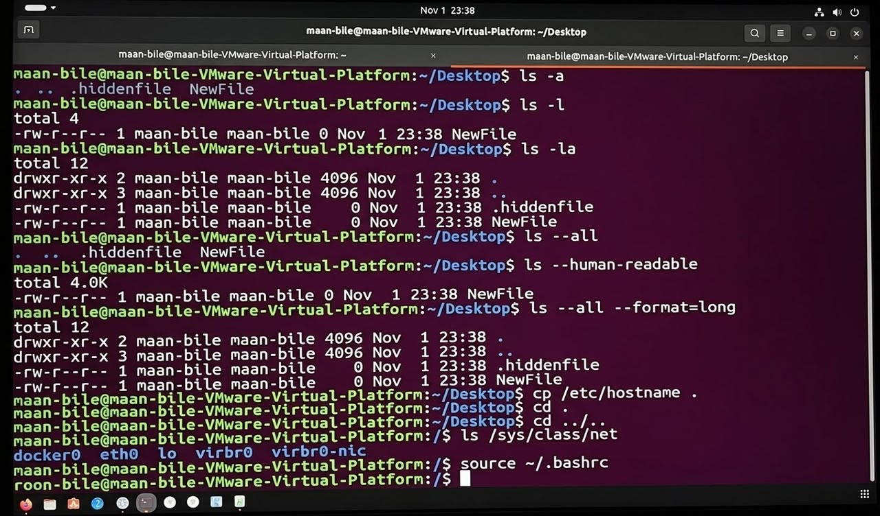

1. Command: ls -a
* This command displays all files and directories in your current location, including hidden files.
* The -a flag stands for "all," revealing even the files that start with a dot (dot files).
* In the image, it output files like .hiddenfile and NewFile, showing both exist there.
* It is a very important tool when you need to see system or standard files hidden from normal view.
2. Command: ls -l
* This command displays files in a detailed long-listing format.
* It shows you file permissions, the number of links, the owner, the group, and the file size.
* Additionally, it displays the date and time when the file was last modified or created.
* The image shows it output detailed information for NewFile and its overall size of total 4.
3. Command: ls -la
* This command is a combination of the previous two commands and is one of the most used in Linux.
* It displays all hidden and normal files using the detailed long format (-l and -a).
* You can clearly see in the image that it listed folders like . and .. alongside their permissions and other files.
* It gives the user a complete overview of everything inside the directory they were standing in.
4. Command: ls --all
* This command is the long-option format of the ls -a command.
* It performs the exact same function, but uses the full word instead of a short flag.
* It lists all hidden files and folders contained within your working directory.
* It helps people learning Linux easily understand what the command does without memorizing short letters.
5. Command: ls --human-readable
* This command displays file sizes in a format that humans can easily read (such as KB, MB, GB).
* Instead of showing raw byte counts that are hard to calculate, it converts them into understandable sizes.
* Inside the image, it shows an output of total 4.0K representing the overall size of the directory.
* It is very useful when dealing with large files that require their sizes to be quickly identified.
6. Command: ls --all --format=long
* This command combines two options: --all and --format=long.
* It is identical to the ls -la command, but uses full, descriptive words.
* It lists all hidden and normal files in a detailed, long list format.
* It demonstrates how Linux provides multiple options that perform the same task but can be written in different ways.
7. Command: cp /etc/hostname .
* This command copies the file located at /etc/hostname and brings it into your current directory.
* The dot symbol (.) at the end represents the "current directory".
* It allows you to copy important system files from a remote path and bring them to your workspace.
* This is a very important command for file management and making secondary backup copies in Linux.
8. Command: cd .
* This command enters or returns you to the exact same directory you were already in.
* The single dot (.) represents the current directory or where your pointer is.
* It is rarely used directly by itself since it changes nothing, but it is useful inside scripts.
* It ensures the system does not move anywhere else and stays right where it is.
9. Command: cd ../..
* This command moves you up by two levels or directories consecutively.
* The double-dot symbol (..) stands for the parent directory above where you are.
* When combined (../..), it means stepping backward twice toward the higher-level directory.
* It quickly allows you to exit deep folders and step up into a higher part of the system.
10. Command: ls /sys/class/net
* This command displays the contents inside the system directory /sys/class/net.
* This folder contains information regarding the network interfaces connected to the machine.
* As shown in the image, it output names like docker0, eth0, lo, and others.
* It helps network administrators see the active ports and internet hardware running on the machine.
11. Command: source ~/.bashrc
* This command reloads or reads the bashrc configuration file without closing the terminal.
* Any new or modified settings you added to that file become active immediately.
* It allows your changes to reflect within the currently open terminal session.
* It is a command frequently used by developers when setting up a new environment or environment variable.
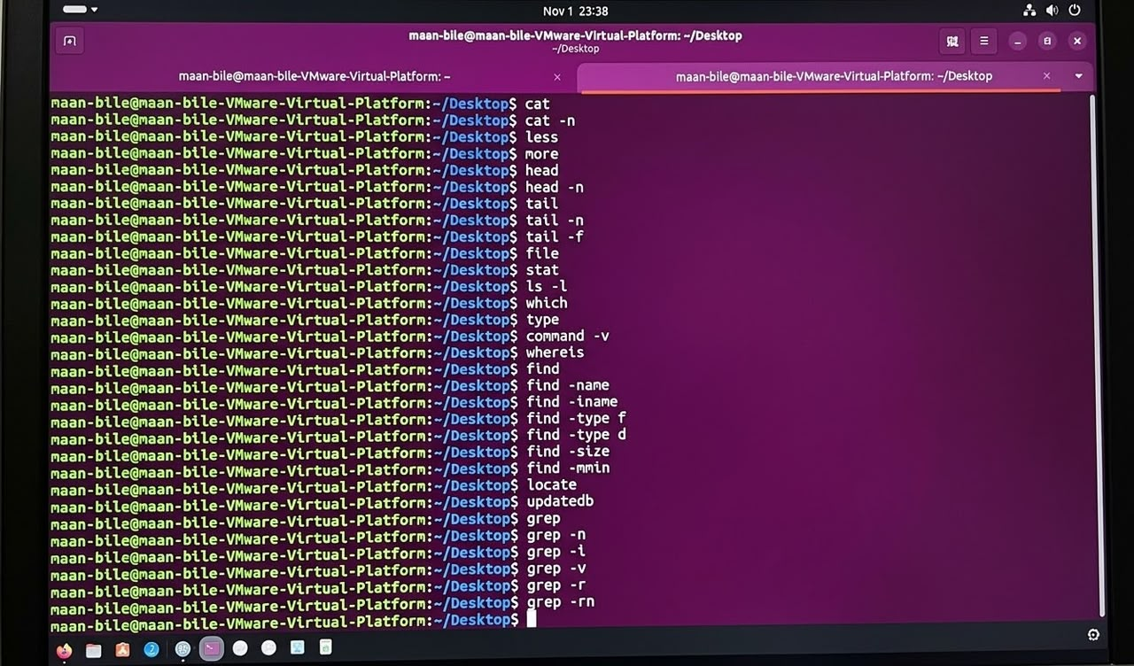

1. Command: cat
* This command is used to concatenate and display the contents of files on the terminal screen.
* It reads data from files and outputs them sequentially to standard output without pagination.
* It is commonly used for quickly viewing small files or combining multiple files together.
* It is a fundamental and frequently used file utility tool within Unix and Linux systems.
2. Command: cat -n
* This command displays the contents of a file while numbering every single line in the output.
* The -n flag stands for number, adding line numbers automatically on the left side.
* It is extremely useful when debugging code, scripts, or reviewing configuration files line by line.
* It helps users easily reference specific lines during troubleshooting or collaborative editing tasks.
3. Command: less
* This command allows you to view the contents of a file page by page or scroll through it interactively.
* Unlike cat, it loads files dynamically, making it efficient for navigating very large text files.
* You can use the arrow keys or spacebar to scroll up and down, and press 'q' to exit.
* It prevents terminal clutter by fitting the output cleanly to your screen dimensions.
4. Command: more
* This command is a classic pager tool used to display text files one screenful at a time.
* As you view the text, you can press the spacebar to advance downward or 'q' to quit.
* It is an older alternative to less, though less offers more advanced navigation features.
* It remains useful for inspecting long log files or documentation outputs within terminal sessions.
5. Command: head
* This command outputs the first part—specifically the first 10 lines—of any given text file.
* It gives you a quick snapshot of a file's structure without opening its entirety.
* By default, it prints 10 lines, but this limit can be customized using additional options.
* It is frequently used in scripts or quick checks to verify the headers of data files.
6. Command: head -n
* This command specifies an exact number of lines to display from the beginning of a file.
* The -n option is followed by a number indicating how many top lines you want to see.
* For example, using -n 5 would show only the first five lines of the target file.
* It provides precise control when you only need a specific header snippet from a document.
7. Command: tail
* This command outputs the last part—specifically the final 10 lines—of a given text file.
* It is the exact opposite counterpart to the head command utility.
* By default, it displays the tail end of logs or files to check recent entries.
* It helps administrators quickly review the most recent updates or errors recorded in logs.
8. Command: tail -n
* This command allows you to specify the exact number of lines to view from the end of a file.
* By combining tail with -n and a number, you control how many bottom lines appear.
* It helps filter out unnecessary older data to focus strictly on the most recent lines.
* It is widely used in text processing pipelines and routine system maintenance checks.
9. Command: tail -f
* This command tracks file growth in real-time, outputting appended data as it updates.
* The -f option stands for "follow," keeping the terminal session open to watch live changes.
* It is the ultimate tool for monitoring live system logs, server errors, or activity streams.
* You can terminate the live following process at any time by pressing Ctrl + C.
10. Command: file
* This command determines and classifies the actual data type of a specified file.
* It analyzes file headers and content rather than relying solely on file extensions.
* It can tell you whether a file is plain text, an executable, an archive, or an image.
* It helps troubleshoot unknown files by revealing their true format instantly.
11. Command: stat
* This command displays detailed status information and metadata about a file or filesystem.
* It shows file size, blocks, device details, inode numbers, and access permissions.
* It also provides precise timestamps for when the file was accessed, modified, and changed.
* It offers a deeper and more technical breakdown than a standard ls -l listing.
12. Command: ls -l
* This command lists files in a long format displaying detailed permissions and ownership.
* It shows read, write, and execute privileges alongside hard link counts and sizes.
* It prints modification dates and times for each item inside the directory.
* It is an essential command for auditing directory contents and file attributes.
13. Command: which
* This command locates the executable file associated with a given command name.
* It searches through the directories listed in your system's PATH environment variable.
* It returns the full absolute path of the program that will run when typed.
* It helps verify whether a software package is installed and where its binary resides.
14. Command: type
* This command indicates how a given command name would be interpreted by the shell.
* It tells you whether a command is a shell builtin, an alias, a function, or an external binary.
* It helps clarify why a command behaves in a certain way within the current shell session.
* It is a helpful diagnostic tool for shell scripting and environment inspection.
15. Command: command -v
* This command looks up a command name and prints the path or description of it.
* It is often preferred in robust shell scripts because it behaves predictably across shells.
* It bypasses shell aliases and functions to find the actual executable command path.
* It ensures scripts call the intended system binary rather than a customized alias.
16. Command: whereis
* This command locates the binary, source, and manual page files for a specified command.
* It searches standard system directories rather than relying solely on the user's PATH variable.
* It provides a broader search scope than which by including documentation files.
* It helps system administrators find hidden components or documentation associated with tools.
17. Command: find
* This command searches for files and directories across a directory hierarchy based on criteria.
* It supports powerful filters including name, size, type, and modification time parameters.
* It can also execute secondary commands on the files matching your search query.
* It is one of the most versatile and comprehensive search utilities in Linux.
18. Command: find -name
* This command searches for files within a directory tree matching a specific filename pattern.
* The -name flag is case-sensitive, meaning exact capitalization must match.
* It allows wildcard characters like asterisks to find broad file patterns easily.
* It is the standard approach for tracking down misplaced files in large directory structures.
19. Command: find -iname
* This command performs a case-insensitive filename search across a directory structure.
* The -iname option ignores uppercase and lowercase differences during the matching process.
* It is useful when you forget the exact capitalization of a file you are looking for.
* It broadens your search results to catch any variant of the target file name.
20. Command: find -type f
* This command restricts a find search specifically to regular files within a directory.
* The -type f filter ignores directories, symbolic links, and other special file types.
* It streamlines searches when you only want to process or locate actual document files.
* It helps target data precisely without cluttering results with folder paths.
21. Command: find -type d
* This command restricts a find search specifically to directories or folders.
* The -type d filter ignores regular files and focuses purely on folder structures.
* It is useful when analyzing directory trees or mapping out nested folder layouts.
* It helps administrators quickly locate subdirectories matching specific structural rules.
22. Command: find -size
* This command searches for files based on their specific storage size requirements.
* It accepts modifiers like plus or minus signs to find files larger or smaller than a threshold.
* You can specify sizes using blocks, kilobytes, megabytes, or gigabytes.
* It is vital for cleaning up disk space by targeting oversized files quickly.
23. Command: find -mmin
* This command searches for files based on how many minutes ago they were last modified.
* The -mmin flag measures modification time in minutes relative to the current time.
* It allows precise tracking of recent file changes or newly generated system logs.
* It helps developers pinpoint files modified during a specific short testing window.
24. Command: locate
* This command finds files by searching through a precompiled system database index.
* Because it queries an index rather than scanning the live disk, it runs extremely fast.
* It requires the index database to be updated periodically to reflect recent file changes.
* It is ideal for instantaneous global file searches across the entire operating system.
25. Command: updatedb
* This command updates the background file name database used by the locate command.
* It scans the filesystem to index newly created or modified files and directories.
* It typically runs automatically via cron jobs, but can be triggered manually.
* It ensures that subsequent locate searches return accurate, up-to-date results.
26. Command: grep
* This command searches text files for matching patterns, strings, or regular expressions.
* It prints every line that contains a match for your specified search term.
* It is a cornerstone text-filtering tool utilized heavily in scripting and log analysis.
* It helps isolate relevant information out of massive text blocks or configuration files.
27. Command: grep -n
* This command searches for text patterns and outputs matching lines alongside their line numbers.
* The -n flag adds line numbering context to every matched result line.
* It makes it easy to locate where specific configuration properties or errors exist in files.
* It saves time by pointing directly to the exact location within the source file.
28. Command: grep -i
* This command performs a case-insensitive text search using the grep utility.
* The -i flag ignores differences between uppercase and lowercase letters.
* It ensures you match your target string regardless of how it is capitalized in the file.
* It broadens search accuracy when looking through inconsistently formatted logs.
29. Command: grep -v
* This command inverts the search match, printing only lines that do NOT contain the pattern.
* The -v flag acts as a "invert match" filter to exclude specific strings.
* It is useful for filtering out noise, comments, or blank lines from command outputs.
* It helps isolate clean data streams by stripping away unwanted log entries.
30. Command: grep -r
* This command searches recursively through all files in a directory and its subdirectories.
* The -r option dives down into nested folder structures automatically.
* It allows you to find keyword occurrences across an entire project or codebase at once.
* It is an indispensable tool for programmers and system auditors searching project directories.
31. Command: grep -rn
* This command combines recursive searching (-r) with line numbering (-n) outputs.
* It scans every file across subdirectories and prints matching lines with their exact line numbers.
* It is one of the most practical combinations for code searches and configuration audits.
* It instantly tells you the file path, line number, and content of every matching occurrence.
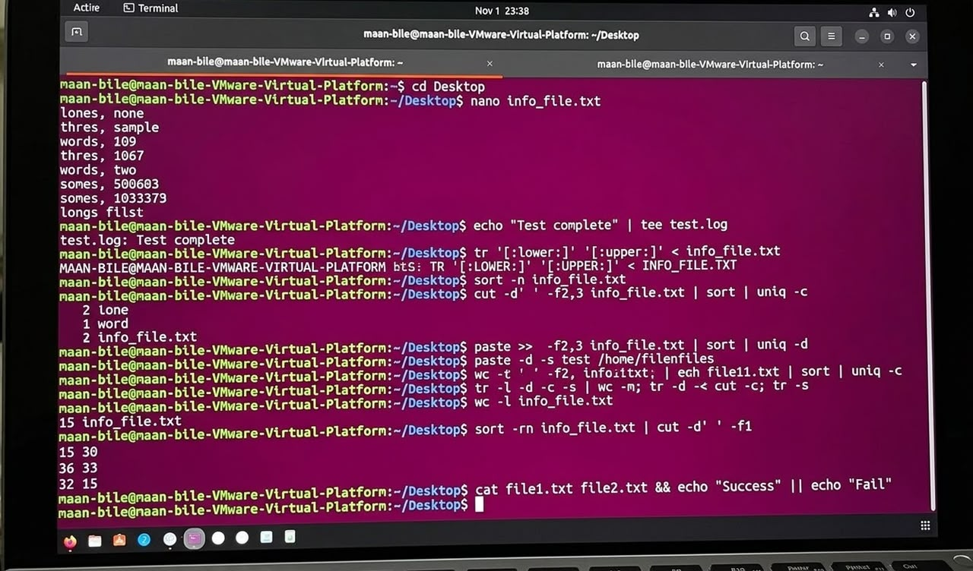

1. cd Desktop
- This command changes the current working directory to the Desktop folder.
- It allows the user to access files and folders stored on the Desktop.
- It helps users move from one directory to another in the Linux terminal.
- It is commonly used to navigate between directories in Linux.
2. nano info_file.txt
- This command opens the info_file.txt file using the Nano text editor.
- Nano is a simple and beginner-friendly text editor in Linux.
- It allows users to create, view, and edit text files.
- Users can save changes and exit the editor using keyboard shortcuts.
3. echo "Test complete" | tee test.log
- The echo command displays the text "Test complete" on the screen.
- The pipe symbol (|) sends the output to the tee command.
- The tee command saves the text inside the test.log file.
- It displays the text on the screen and saves a copy in the file.
4. tr '[:lower:]' '[:upper:]' < info_file.txt
- The tr command is used to translate or change characters.
- It converts all lowercase letters into uppercase letters.
- The < symbol takes input from the info_file.txt file.
- The converted text is displayed on the terminal screen.
5. sort -n info_file.txt
- The sort command is used to arrange lines in a text file.
- The -n option sorts numbers according to their numerical values.
- It arranges numbers from the smallest to the largest.
- The sorted results are displayed on the terminal screen.
6. cut -d' ' -f2,3 info_file.txt | sort | uniq -c
- The cut command extracts specific fields from each line of a file.
- The -d' ' option uses a space as the field separator.
- The -f2,3 option selects the second and third fields.
- The sort and uniq -c commands arrange the results and count repeated lines.
7. paste >> -f2,3 info_file.txt | sort | uniq -d
- The paste command is used to combine lines from files.
- The >> symbol appends output to a file.
- The sort command arranges the input before further processing.
- The uniq -d command displays duplicate adjacent lines.
Note
This command appears to contain syntax errors. It may need correction depending on the original command.
8. paste -d -s test /home/filenfiles
- The paste command combines lines from one or more files.
- The -d option specifies the delimiter between the combined values.
- The -s option combines lines from each file into a single line.
- It is useful for joining and organizing text data.
9. wc -t ' ' -f2, infoiittxt; | egh file11.txt | sort | uniq -c
- The wc command is used to count lines, words, and characters.
- The command appears to contain incorrect options and spelling mistakes.
- The pipe symbol (|) sends output from one command to another.
- The sort and uniq -c commands can arrange and count repeated lines.
10. tr -l -d -c -s | wc -m; tr -d -< cut -c; tr -s
- The tr command is used to translate, delete, or squeeze characters.
- The -d option deletes specified characters from the input.
- The wc -m command counts the number of characters.
- The semicolon (;) separates multiple commands in the terminal.
11. wc -l info_file.txt
- The wc command is used to count information in a text file.
- The -l option tells Linux to count only the lines.
- It reads the contents of the info_file.txt file.
- The total number of lines is displayed on the terminal screen.
12. sort -rn info_file.txt | cut -d' ' -f1
- The sort command arranges the contents of a text file.
- The -r option sorts the results in reverse order.
- The -n option sorts numbers according to their numerical values.
- The cut command extracts the first field from each line.
13. cat file1.txt file2.txt && echo "Success" || echo "Fail"
- The cat command displays the contents of two text files.
- The && operator executes the next command if the previous command succeeds.
- The echo "Success" command displays Success when the files are read successfully.
- The || operator displays Fail if the previous command fails.
Fiiro gaar ah: Commands 7, 9 iyo 10 waxay u muuqdaan inay leeyihiin khaladaad syntax ah. Sharaxaaddoodu waa mid guud, mana aha in loo qaato inay sidaas sax ugu shaqaynayaan Linux.

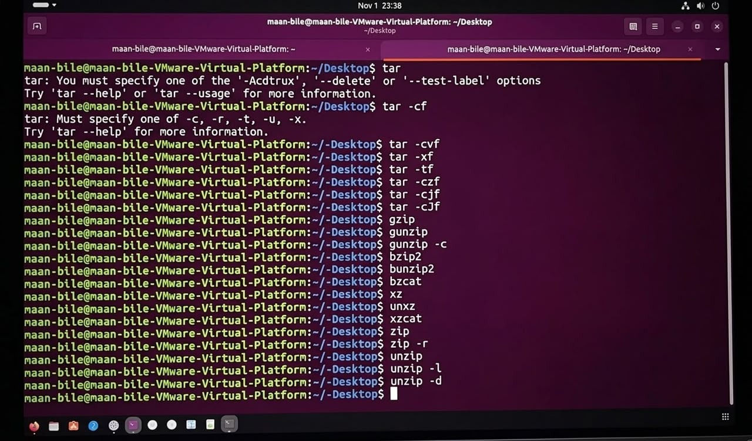

Waxaan kuu habeeyey dhammaan 22-ka Linux commands. Mid kasta waxaan ka dhigay 4 sadar oo English fudud ah, lambarradana si sax ah ayaan u kala hormariyey.
1. tar
- The tar command is used to combine multiple files into one archive file.
- It helps users store and organize many files in a single file.
- It supports different operations such as creating, extracting, and listing archives.
- Users can type tar --help to see all available options and commands.
2. tar -cf
- The tar -cf command is used to create a new archive file.
- The -c option means create, and the -f option specifies the archive filename.
- It allows users to combine multiple files and folders into one archive.
- Users must specify the archive name and the files they want to include.
3. tar -cvf
- The tar -cvf command is used to create an archive with multiple files.
- The -c option creates the archive, while -v displays the files being added.
- The -f option specifies the name of the archive file.
- It helps users monitor the files while creating an archive.
4. tar -xf
- The tar -xf command is used to extract files from an archive.
- The -x option means extract, and the -f option specifies the archive file.
- It restores the archived files into the current working directory.
- Users must provide the correct archive filename to extract its contents.
5. tar -tf
- The tar -tf command is used to display the contents of an archive.
- The -t option lists the files, while -f specifies the archive filename.
- It shows the names of files and folders stored inside the archive.
- It allows users to check archive contents without extracting them.
6. tar -czf
- The tar -czf command creates a compressed archive using Gzip.
- The -c option creates the archive, and -z enables Gzip compression.
- The -f option specifies the name of the archive file.
- It creates a compressed file that usually ends with .tar.gz.
7. tar -cjf
- The tar -cjf command creates an archive using Bzip2 compression.
- The -c option creates the archive, while -j enables Bzip2 compression.
- The -f option specifies the archive filename.
- It creates a compressed file that usually ends with .tar.bz2.
8. tar -cJf
- The tar -cJf command creates an archive using Xz compression.
- The -c option creates the archive, while -J enables Xz compression.
- The -f option specifies the name of the archive file.
- It creates a compressed archive that usually ends with .tar.xz.
9. gzip
- The gzip command is used to compress files in Linux.
- It reduces file size to save storage space.
- It usually replaces the original file with a compressed .gz file.
- It is useful for compressing large files and saving disk space.
10. gunzip
- The gunzip command is used to decompress Gzip files.
- It restores compressed .gz files to their original form.
- It normally removes the .gz extension after extraction.
- It helps users recover files that were compressed using Gzip.
11. gunzip -c
- The gunzip -c command displays the decompressed content of a Gzip file.
- The -c option sends the output directly to standard output.
- It allows users to read compressed files without deleting the original file.
- It can also be used with redirection to save the output into another file.
12. bzip2
- The bzip2 command is used to compress files in Linux.
- It uses the Bzip2 compression method to reduce file size.
- It usually replaces the original file with a .bz2 file.
- It is useful for compressing large files and saving storage space.
13. bunzip2
- The bunzip2 command is used to decompress Bzip2 files.
- It restores .bz2 files to their original form.
- It normally removes the compressed file after successful extraction.
- It helps users recover files that were compressed using Bzip2.
14. bzcat
- The bzcat command is used to read Bzip2-compressed files.
- It displays the decompressed content directly on the terminal.
- It allows users to view .bz2 files without extracting them.
- It is useful for checking compressed text files and log files.
15. xz
- The xz command is used to compress files in Linux.
- It uses the Xz compression method to reduce file size.
- It usually creates compressed files with the .xz extension.
- It is useful for compressing large files and saving storage space.
16. unxz
- The unxz command is used to decompress Xz-compressed files.
- It restores .xz files to their original form.
- It normally removes the compressed file after successful extraction.
- It helps users recover files that were compressed using Xz.
17. xzcat
- The xzcat command is used to read Xz-compressed files.
- It displays the decompressed content directly on the terminal.
- It allows users to view .xz files without extracting them.
- It is useful for reading compressed documents and log files.
18. zip
- The zip command is used to compress files and folders.
- It combines multiple files into one .zip archive.
- It helps users save storage space and organize files.
- It is commonly used to share files between different operating systems.
19. zip -r
- The zip -r command is used to compress entire directories.
- The -r option means recursive and includes files inside subfolders.
- It allows users to compress folders with all their contents.
- It is useful for backing up and sharing complete directories.
20. unzip
- The unzip command is used to extract files from a ZIP archive.
- It restores the compressed files to their original form.
- It normally extracts the files into the current working directory.
- It is commonly used to open and manage .zip files in Linux.
21. unzip -l
- The unzip -l command is used to list the contents of a ZIP archive.
- The -l option displays the files without extracting them.
- It shows file names, sizes, dates, and directory paths.
- It helps users check the contents before extracting the archive.
22. unzip -d
- The unzip -d command is used to extract ZIP files into a specific directory.
- The -d option specifies the destination folder.
- It allows users to choose where the extracted files should be saved.
- It helps organize extracted files and keeps directories clean.
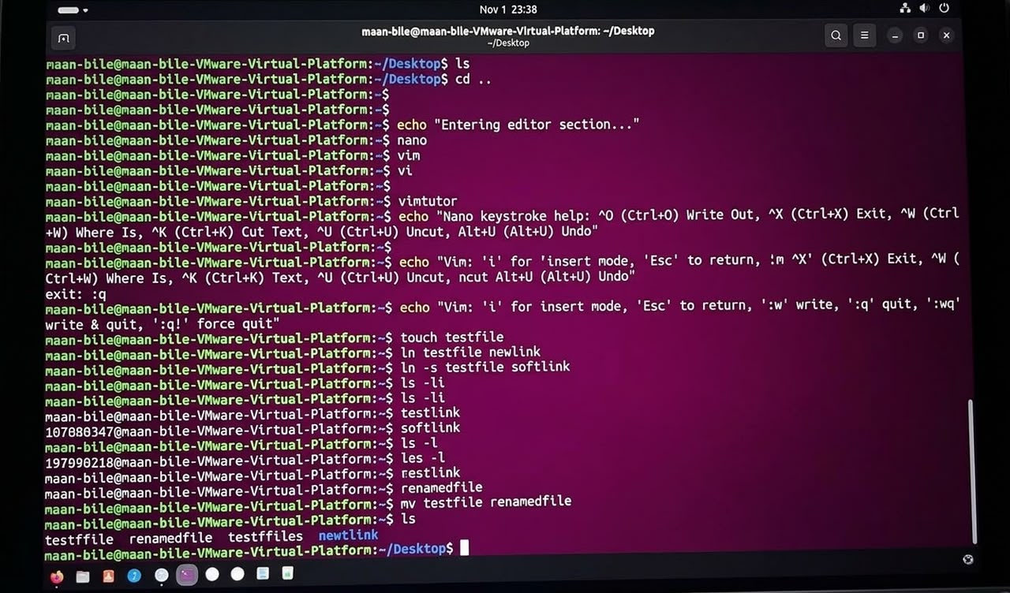

1. ls
- The ls command displays files and folders in a directory.
- It helps users see the available files in the current location.
- It makes it easier to find and manage files and folders.
- It is one of the most commonly used Linux commands.
2. cd ..
- The cd .. command moves to the parent directory.
- The double dots (..) represent one directory level above.
- It allows users to move back from the current folder.
- It is commonly used for navigating the Linux file system.
3. echo "Entering editor section..."
- The echo command displays text on the terminal screen.
- It prints the message "Entering editor section..." to the screen.
- It is commonly used to display information in shell scripts.
- It helps users identify different sections of terminal operations.
4. nano
- The nano command opens a simple text editor in Linux.
- It allows users to create and edit text files.
- Running it without a filename opens a blank editing screen.
- It is easy to use because it displays keyboard shortcuts at the bottom.
5. vim
- The vim command opens the Vim text editor in Linux.
- It is an advanced editor used for writing and editing files.
- It supports different modes, such as Insert Mode and Command Mode.
- It is commonly used by programmers and system administrators.
6. vi
- The vi command opens the traditional Unix text editor.
- It allows users to create and edit text files.
- It uses different modes for typing and editing text.
- It is commonly available on Linux and Unix systems.
7. vimtutor
- The vimtutor command opens an interactive Vim tutorial.
- It teaches users how to use the Vim text editor.
- It provides practical exercises for editing and navigating files.
- It is useful for beginners who want to learn Vim.
8. echo "Nano keystroke help: ^O (Ctrl+O) Write Out, ^X (Ctrl+X) Exit, ^W (Ctrl+W) Where Is, ^K (Ctrl+K) Cut Text, ^U (Ctrl+U) Uncut, Alt+U (Alt+U) Undo"
- The echo command displays Nano keyboard shortcuts on the terminal.
- Ctrl+O saves the file, while Ctrl+X exits the editor.
- Ctrl+W searches text, and Ctrl+K cuts a line.
- Ctrl+U pastes cut text, while Alt+U undoes the last action.
9. echo "Vim: 'i' for 'insert mode', 'Esc' to return, :m 'X' (Ctrl+X) Exit, :W (Ctrl+W) Where Is, ^K (Ctrl+K) Text, ^U (Ctrl+U) Uncut, ncut Alt+U (Alt+U) Undo"
- The echo command displays information about Vim keyboard shortcuts.
- The i key enters Insert Mode, while Esc returns to Normal Mode.
- Vim uses commands such as :w to save and :q to quit.
- It helps users remember important keyboard shortcuts for editing files.
Correction
The original shortcut text contains mistakes. The correct Vim shortcuts are :w, :q, :wq, and :q!.
10. exit
- The exit command closes the current shell session.
- It terminates the command interpreter running in the terminal.
- It is commonly used when users finish working in the terminal.
- It helps users safely leave a Linux shell session.
11. :q
- The :q command is used to quit the Vim editor.
- It works when there are no unsaved changes in the file.
- If changes are not saved, Vim prevents the editor from closing.
- Users must type :q in Vim command mode to exit.
12. echo "Vim: 'i' for insert mode, 'Esc' to return, ':w' write, ':q' quit, ':wq' write & quit, ':q!' force quit"
- The echo command displays important Vim commands on the terminal.
- The i key enters Insert Mode, while Esc returns to Normal Mode.
- The :w command saves the file, and :q closes the editor.
- The :wq command saves and exits, while :q! exits without saving changes.
13. touch testfile
- The touch command creates a new empty file named testfile.
- It creates the file in the current working directory.
- If the file already exists, it updates its modification timestamp.
- It is commonly used to create empty files in Linux.
14. ln testfile newlink
- The ln command creates a hard link to an existing file.
- It creates a new link named newlink pointing to testfile.
- Both names refer to the same file data and inode number.
- It allows users to access the same file using different names.
15. ln -s testfile softlink
- The ln -s command creates a symbolic link in Linux.
- It creates a link named softlink pointing to testfile.
- A symbolic link works like a shortcut to the original file.
- If the original file is deleted, the symbolic link becomes broken.
16. ls -li
- The ls -li command displays detailed information about files.
- The -l option shows file permissions, size, owner, and date.
- The -i option displays the inode number of each file.
- It helps users identify files and check hard links in Linux.
17. testlink
- This command attempts to execute a program named testlink.
- Linux searches for the command in the available system paths.
- If the command does not exist, the terminal displays an error.
- It is not a standard Linux command.
18. 10708037@maan-blle...
- This output represents information displayed by the Linux terminal.
- The number may represent an inode number shown by the ls -li command.
- The remaining text may contain file or directory information.
- It helps users identify files and understand their system information.
19. ls -l
- The ls -l command displays files in a detailed list format.
- It shows file permissions, owner, group, size, and modification date.
- It helps users understand the properties of files and directories.
- It is commonly used to check file information in Linux.
20. les -l
- The les -l command appears to contain a spelling mistake.
- The correct command may be less for viewing text files.
- The less command allows users to read files page by page.
- It helps users navigate long text files without displaying everything at once.
21. restlink
- This line represents an attempt to execute a command named restlink.
- It is not a standard Linux command.
- If the command does not exist, Linux displays a command-not-found error.
- It may represent a test or typing mistake in the terminal.
22. renamedfile
- This line represents an attempt to execute a command named renamedfile.
- It may refer to a file created or renamed earlier.
- A filename alone does not display the file contents.
- Users can use cat or ls to work with the file.
23. mv testfile renamedfile
- The mv command is used to move or rename files and directories.
- It changes the filename from testfile to renamedfile.
- The command preserves the contents of the file during renaming.
- It is commonly used to organize and manage files in Linux.

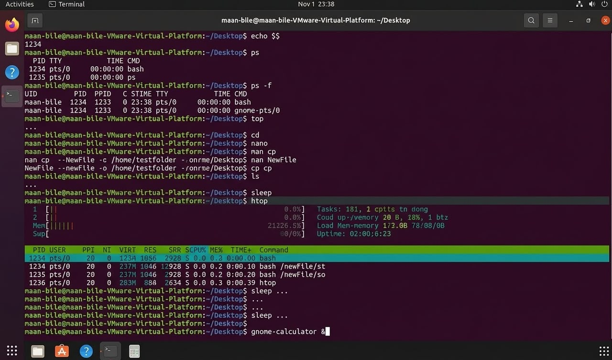

1. echo $$
- This command prints the process ID (PID) of the current shell session.
- It outputs numbers like 1234 representing the active shell process identifier.
- It is useful for scripting and tracking active terminal instances.
- It allows users to query system process details directly from the prompt.
2. ps
- The ps command reports a snapshot of the current processes running in the system.
- It displays details like PID (Process ID), TTY (terminal type), and TIME.
- By default, it shows processes associated with the current shell session.
- It is a foundational diagnostic tool for system monitoring.
3. ps -f
- The -f flag stands for full-format listing in the ps command utility.
- It displays detailed columns including UID, PID, PPID, C, STIME, TTY, and CMD.
- This helps users see parent-child relationships between different active processes.
- It provides a more comprehensive view of user process execution data.
4. top
- The top command displays a dynamic, real-time view of running system processes.
- It shows system resource usage including CPU and memory utilization summaries.
- It allows administrators to monitor and manage system performance live.
- Users can press q to exit the top interface and return to the shell prompt.
5. cd
- The cd command changes the current working directory in Linux.
- Running it alone typically returns the user back to their home directory.
- It is one of the most frequently used navigation commands in the terminal.
- It helps users traverse and organize their file system directories efficiently.
6. nano
- The nano command opens the beginner-friendly terminal text editor.
- It enables users to create, view, and modify text files interactively.
- Shortcut keys are conveniently displayed at the bottom of the interface.
- It is widely used for quick configuration file edits in Linux.
7. man cp
- The man command displays the manual pages for specified utilities.
- Here, it opens the official documentation manual for the cp copy command.
- It provides detailed explanations of command syntax, flags, and behaviors.
- Users can scroll through the manual and press q to exit.
8. nan cp --NewFile -c /home/testfolder ...
- This line represents experimental or mistyped text-editing and copying sequences.
- It combines elements of text commands and directory paths like /home/testfolder.
- Such incorrect syntax typically results in command-not-found error outputs.
- It reflects iterative command experimentation in the user's terminal session.
9. NewFile --NewFile -o /home/testfolder ...
- This appears as a custom command string or test input entry in the shell.
- It attempts to pass options like -o to a file-handling path structure.
- Standalone text entries without valid executables trigger shell errors.
- It demonstrates testing command structures inside the terminal window.
10. cp cp
- This command attempts to use the copy utility (cp) with improper arguments.
- The cp command requires source and destination paths to copy files properly.
- Running it incorrectly prompts syntax errors from the shell environment.
- It highlights syntax validation checks performed by Linux utilities.
11. ls
- The ls command lists the files and directories in the current folder.
- It helps users verify file availability before performing operations.
- It is an essential directory listing utility in Linux systems.
- It provides quick visual feedback on workspace contents.
12. sleep
- The sleep command suspends execution for a specified amount of time.
- Running it without time parameters prompts a missing argument error.
- It is commonly used in shell scripts to create deliberate pauses.
- It controls the timing flow of automated batch operations.
13. htop
- The htop command opens an interactive, colorized process viewer.
- It provides a much more user-friendly interface than the standard top command.
- Users can view CPU gauges, memory usage, and kill processes easily.
- It is a favorite system monitoring tool for Linux administrators.
14. gnome-calculator &
- This command launches the graphical GNOME Calculator application.
- The ampersand (&) at the end runs the process in the background.
- It frees up the terminal prompt so the user can keep typing other commands.
- It bridges command-line control with desktop GUI applications seamlessly.

